

Cardiovascular Research Capacity Program

Aboriginal Heart Health Grants 2025

Stream 1 - Full Application Form v1
Please note that full application stage is by invitation only.

KEY DATES

Call for Expressions of Interest open | 2 October 2024
Information webinar for Expressions of Interest | 16 October 2024
Registration for Sax Support close | 18 October 2024
Expressions of Interest close | 13 December 2024 (5pm AEDT)
Applicants notified of Expressions of Interest outcome  Full Application by invitation only. | 23 May 2025
Information webinar for Full Applications | 11 June 2025
Full applications close | 29 August 2025 (5pm AEST)
Applicants notified of Full Application outcome | By 19 December 2025
Research commences | February 2026

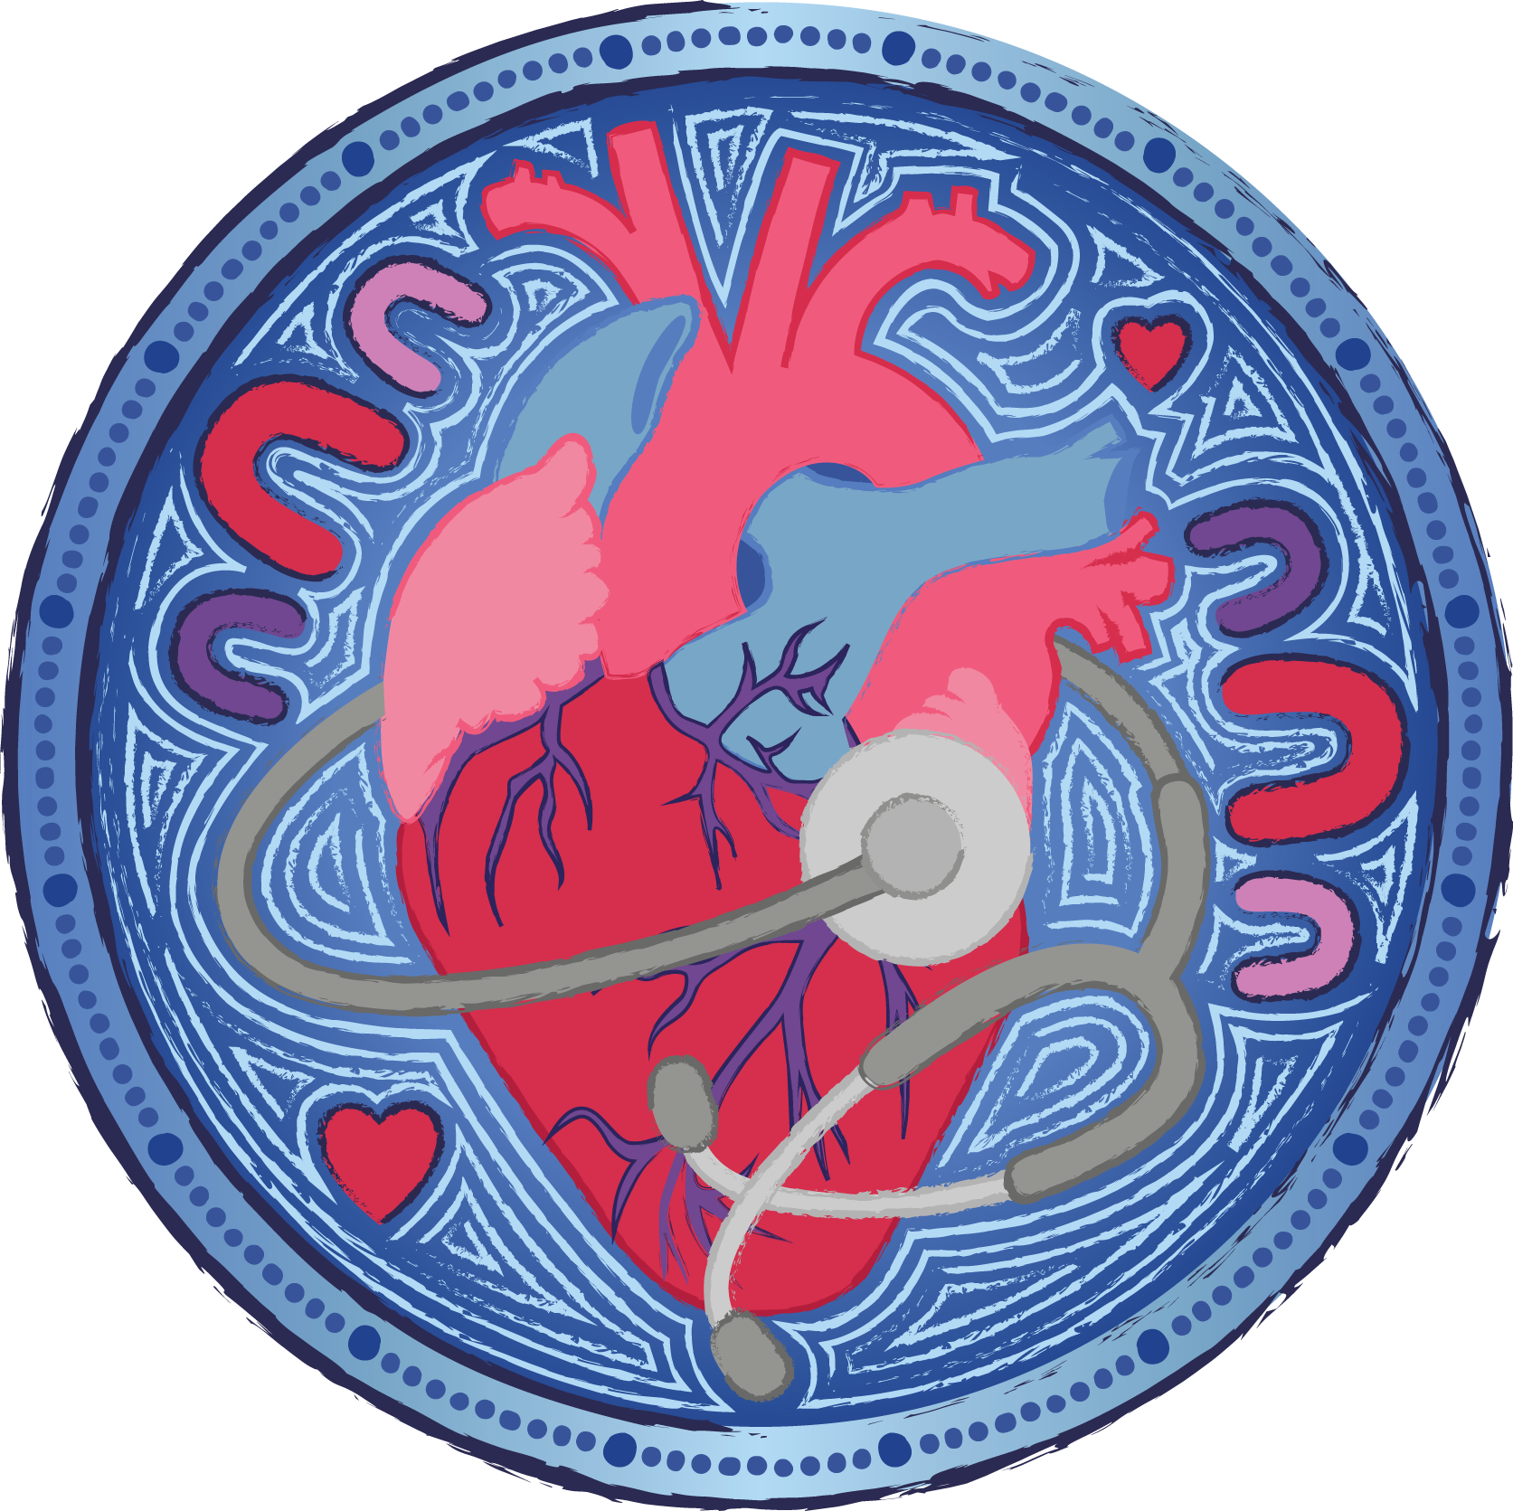

INSTRUCTIONS
Please use this form to develop your application then submit it via email.

Grant Guidelines
Please refer to the 2024 Aboriginal Heart Health Grant Guidelines. The Guidelines outline the program objectives, timelines, eligibility and selection criteria, and other key information and are available on the Cardiovascular Grants page on the NSW Health and Medical Research website.

Word Counts
Word counts in this application form are indicative of the length of response required but are not always a strict requirement and should be used as a guideline rather than a hard limit.

Submission Instructions for Researchers/Applicants
Submit applications to your Host organisation.

Submission Instructions for Host and Administering Organisations
A complete application form and all related documents must be submitted by email to MOH-OHMRGrants@health.nsw.gov.au by 5pm (AEST) on 29 August 2025.
Late or incomplete applications will not be accepted.
NSW Health will acknowledge receipt of your application by email within 72 hours. It is the applicant’s responsibility to follow up if no acknowledgement email is received by emailing MOH-OHMRGrants@health.nsw.gov.au.

The maximum email size is 20MB. Larger emails will be rejected by the NSW Health server and you may not be notified that the email has been rejected. If your email and attachments are larger than this, please send the attachments in multiple emails, ensuring individual emails are no larger than 20MB.

Two versions of the application should be submitted:
- A Word version
- A PDF version

If applicable, applicants may attach other documents, for example:
- a list of references supporting the science.
- a letter of support from Aboriginal Community-Controlled Organisations who have been consulted or who are supporting the project.

Please save your application using the following format for naming and in the email subject line:
Stream 1_SURNAME_First Name (e.g. Stream 1_COHEN_John).

For each additional attachment, use the following format for naming:
Stream 1_SURNAME_ First Name_document name
(e.g. Stream 1_SMITH_Mary_References)

CONTENTS
Section | Content | Page
A | Overview and administrative information | 4
B | Background to the project and impact | 7
C | Co-creation with Aboriginal peoples | 9
D | Research proposal | 10
E | Research team, governance and stakeholders consulted | 13
F | Project milestones and budget | 15
G | Aboriginal leadership, skill development and capacity building | 18
H | Declarations | 19

SECTION A: OVERVIEW AND ADMINISTRATIVE INFORMATION

A1. Applicant(s) Details
Lead Chief Investigator Details
The Lead Chief Investigator must identify as Aboriginal and/or Torres Strait Islander
Title: | Associate Professor, Dr, Miss, Mr, Mrs, Professor, etc.
First name:
Family name:
Email:
Phone:
Position/job title:
Organisation Name:
Primary Workplace Address:
Does the Applicant reside in a regional, rural or remote area?  If yes, please provide the MM area for the Applicant’s work address.  For guidance refer to the Modified Monash Model. Areas classified MM 3 to MM 7 are considered rural or remote for the purpose of the Application. | ☐ Yes ☐ No  ☐ MM 3 ☐ MM 4 ☐ MM 5 ☐ MM 6 ☐ MM 7
Applicant’s gender  Gender refers to current gender, which may be different to sex recorded at birth and what is indicated on legal documents. | ☐ Man or male ☐ Woman or female  ☐ Non-binary ☐ Prefer not to answer  ☐ I use a different term (please specify):
Are you a practising clinician? | ☐ Yes ☐ No
If yes:  a. In which area do you practise? | ☐ Aboriginal Health Worker ☐ Aboriginal Health Practitioner  ☐ Nursing ☐ Allied Health ☐ Medical
b. Will you continue clinical duties during this project? | ☐ Yes ☐ No
c. If yes, what will be the FTE split between clinical and research duties? | FTE research:  FTE clinical duties:
Are you of Aboriginal or Torres Strait Islander origin? | ☐ Yes, Aboriginal ☐ Yes, Torres Strait Islander  ☐ Yes, both Aboriginal and Torres Strait Islander
Working Rights  Do you have the right to work in Australia for the duration of the project? | ☐ Yes ☐ No
PhD completion (if relevant)
a. Date conferred (or expected) DD/MM/YYYY
b. University name
Co-Chief Investigator Details (only complete this section, if relevant)
Title: | Associate Professor, Dr, Miss, Mr, Mrs, Professor, etc.
First name:
Family name:
Email:
Phone:
Position/job title:
Organisation Name:
Primary Workplace Address:
Applicant’s gender  Gender refers to current gender, which may be different to sex recorded at birth and what is indicated on legal documents. | ☐ Man or male ☐ Woman or female  ☐ Non-binary ☐ Prefer not to answer  ☐ I use a different term (please specify):
Are you a practising clinician? | ☐ Yes ☐ No
If yes:  a. In which area do you practise? | ☐ Aboriginal Health Worker ☐ Aboriginal Health Practitioner  ☐ Nursing ☐ Allied Health ☐ Medical
b. Will you continue clinical duties during this project? | ☐ Yes ☐ No
c. If yes, what will be the FTE split between clinical and research duties? | FTE research:  FTE clinical duties:
Are you of Aboriginal or Torres Strait Islander origin? | ☐ Yes, Aboriginal ☐ Yes, Torres Strait Islander  ☐ Yes, both Aboriginal and Torres Strait Islander ☐ Neither
Working Rights  Do you have the right to work in Australia for the duration of the project? | ☐ Yes ☐ No
PhD completion (if relevant)
a. Date conferred (or expected) DD/MM/YYYY
b. University name

A2. Host Organisation
Organisation Name:
Contact Person Title: | Associate Professor, Dr, Miss, Mr, Mrs, Professor, etc.
Contact Person First name:
Contact Person Family name:
Contact Person Position:
Address:
Email:
Phone:

A3. Administering Organisation
Only complete this section if the Administering Organisation is different to the Host Organisation
Organisation Name:
Contact Person Title: | Associate Professor, Dr, Miss, Mr, Mrs, Professor, etc.
Contact Person First name:
Contact Person Family name:
Contact Person Position:
Address:
Email:
Phone:

A4. Project Overview
Project Title
Please ensure the title describes the project clearly and avoids overly technical language.
Total funding requested  The maximum request is $750,000. |  | $
Broad Research Area  The primary research focus of this application is (tick only one): |  | ☐ Clinical Medicine and Science Research  ☐ Health Services Research  ☐ Public Health Research
How does this project focus on Aboriginal peoples? |  | ☐ The targeted population focuses on Aboriginal peoples, which means the sample entirely or mainly comprises Aboriginal peoples.  ☐ A whole of population study is required and there is a significant focus on Aboriginal peoples as a primary subgroup in the analysis.
Other priority populations
Does your research focus on the health of one or more priority population? For example:
- Does your intervention specifically target a particular population group?
- Are you analysing the data for particular populations separately?
Please indicate priority population(s) that are the focus of your research. Tick all that are relevant.  Tick: |  |  | For those populations that are a focus of your research, please explain how your research addresses the needs of this priority population and, if relevant, engagement with representatives of the priority population (max 150 words).
People in rural and/or remote communities (MM3-MM7)  Areas MM3 to MM7 are considered rural or remote. For guidance, see the Modified Monash Model. | ☐
Mental Health | ☐
Older people experiencing diseases of aging | ☐
People with rare or currently untreatable diseases/conditions | ☐
People with a disability | ☐
Individuals from culturally and linguistically diverse communities | ☐
LGBTIQ+ people | ☐
Keywords
Parts a. and b. of this question relate to The Australian and New Zealand Standard Research Classification (ANZSRC) 2020 codes https://www.abs.gov.au/AUSSTATS/abs@.nsf/DetailsPage/1297.02020?OpenDocument
a. Please enter 3 Field of Research (FoR) field codes for the project (NB. consider the project’s methodology when selecting codes).
FoR field 1:
FoR field 2:
FoR field 3:
b. Please enter 3 Socio-Economic Objectives (SEO) objective codes for the project (NB. consider the project’s purpose and/or outcome when selecting codes).
SEO objective code 1:
SEO objective code 2:
SEO objective code 3:
c. Please provide up to 4 additional keywords to describe the research. Use keywords from the NHMRC Research Keywords/Phrases list wherever possible: https://www.nhmrc.gov.au/sites/default/files/2019-03/research-keywords.pdf. You may include key words relating to the clinical area (e.g. cancer, stroke), specific populations under study (e.g. children, Aboriginal people), research methods (randomised controlled trial), research type (biobanking, genomics, stem cells) and other descriptive keywords as appropriate.
Additional Keyword 1:
Additional Keyword 2:
Additional Keyword 3:
Additional Keyword 4:

SECTION B: BACKGROUND TO THE PROJECT AND IMPACT

B1. Response to EOI Feedback
Please list the feedback provided to you by the Expert Review Panel on the Expression of Interest and provide responses about how this has been addressed. If you have chosen not to act on the feedback, you can also provide reasoning for this (max 600 words).

B2. Current Experience of Aboriginal Peoples
What is the issue your research is trying to address? Describe the current experience of Aboriginal peoples in relation to your chosen project focus (max 250 words).

B3. Need for this Research
Describe how you identified the need for this research e.g. evidence gap found in literature, health service or consumer feedback (max 300 words).

B4. Perceived Impact of this Project
- Describe the perceived impact of this project for Aboriginal peoples and communities, both positive and negative impacts for participants, and strategies to mitigate negative impacts (if applicable) (max 300 words).

- How will this research elevate Aboriginal voices? (max 150 words)

- How will the knowledge generated from the research be retained in participating Aboriginal communities? (max 150 words)

B5. Alignment with NSW Health Aboriginal Health Plan
How does your research project align with the NSW Health Aboriginal Health Plan? (max 600 words)

SECTION C: CO-CREATION WITH ABORIGINAL PEOPLE

C1. Co-creation and Consultation Process
Describe the co-creation and consultation process. This must have already been undertaken with Aboriginal peoples, communities and/or organisations participating or affected by the research to:
- identify a need/priority for research in the cardiovascular space
- develop a solution/innovation/strategy to address this need/priority
- develop culturally appropriate research methods, outcomes and a feasible plan for translating the research (max 500 words).

C2. Ethical Considerations and Cultural Safety
Describe how ethical considerations have been addressed and that the research project is culturally respectful and safe for Aboriginal people, communities and organisations (max 300 words)

C3. Feedback Loop with Aboriginal Peoples
Describe how there will be a continuous feedback loop with Aboriginal peoples, communities and/or organisations (max 300 words)

SECTION D: RESEARCH PROPOSAL

Use the sections below to provide a full research protocol for your project. It should include how you have:
- identified a need/priority for research in the cardiovascular space
- developed a solution/innovation/strategy to address this need/priority
- developed culturally appropriate research methods, outcomes and a feasible plan for translating the research

Diagrams and charts can be included if needed. A list of references supporting the science may be attached as a separate document.

D1. Research Protocol
- What is the research question to address the issue? (max 100 words)

- Describe the approach, including research design and methods (max 800 words).
Include details such as study design, intervention, sample and setting including control group where appropriate, primary and secondary outcomes, data sources/research tools, data collection methods including time points for baseline and follow-up periods, sample size and power calculations, statistical analysis plan.

- Provide the rationale for the approach and any potential barriers and mitigation strategies (max 150 words).

- What new or relevant evidence will the research project generate for policy and/or practice?
What are the likely impacts of the results of the project on disease prevention at a population level, individual patient care or health service delivery? (max 300 words)

- Comment on the extent to which anticipated outcomes from the research project can be generalised, scaled, translated or embedded into clinical practice.
How will you ensure this occurs? (max 300 words).
In this section you can include details such as:
  - the mechanism/vehicle by which the research findings can be translated into change (e.g. communication with state and local decision maker, funder, committee, network, agency)
  - key stakeholders that you will engage with to scale up your research (e.g. Centre for Aboriginal Health, state-wide clinical networks, other LHDs/speciality networks)
  - how the results of your study can support or integrate with existing State or regional initiatives or health services.

D2. Risk Management Plan
Outline all risks that may impact the achievement of the aims during the funding period and how these risks may be mitigated. Add rows as required.
# | Aim | Risk | Likelihood (low, medium, high) | Mitigation Strategy and Outcome
1
2
3
4
5
 | Add rows if needed

D3. Feasibility of Delivering the Research Project
How can you provide confidence that the research project will be delivered within the specified timeframe and budget? (max 200 words).

D4. Qualitative Evaluation
Will any qualitative evaluation be done? If yes, please provide details. (max 200 words).

D5. Other Funding for this Research Work
Have you applied for or received any other funding to support this research work? If yes, please provide details.
Funding body | Expected date of outcome (if known) | Project title | Grant Amount
Add rows if needed

D7. Lay Summary of the Research Project
Please provide a short summary of your research project which can be used for OHMR website and other communications if your application is successful. Please provide a plain language version and avoid overly technical language and acronyms. For examples, please refer to https://www.medicalresearch.nsw.gov.au/project-directory/
The word counts in section D7 are hard limits rather than approximate.
Project title (max 52 characters including spaces)
Research intent summary statement
Descriptive title that summarises the intent of the research project (max 150 characters including spaces)
What is the issue for NSW?
What is the issue the research will address? (max 120-150 words)
What does the research aim to do and how?
Overview of the research aim and methodology for the project (max 75-100 words)
What are the top 3 key measures/indicators being used to assess the research outcomes?  These should be short and succinct key measures. | 1.  2.  3.
Please provide project related images as a separate attachment.
These may be published with the project summary on www.medicalresearch.nsw.gov.au

SECTION E: RESEARCH TEAM, GOVERNANCE
AND STAKEHOLDERS CONSULTED

E1. Research Team
Please list the Lead Chief Investigator, Co-Chief Investigator (where relevant), Associate Investigator(s), and other key team members in the table below.
# | Title and Full Name | Does this person identify as Aboriginal and/or Torres Strait Islander? | Position | Organisation | Contribution to the project | FTE on the project | Consent provided*
1 |  |  |  |  |  |  | ☐
2 |  |  |  |  |  |  | ☐
3 |  |  |  |  |  |  | ☐
4 |  |  |  |  |  |  | ☐
5 |  |  |  |  |  |  | ☐
6 |  |  |  |  |  |  | ☐
7 |  |  |  |  |  |  | ☐
8 |  |  |  |  |  |  | ☐
9 |  |  |  |  |  |  | ☐
10 |  |  |  |  |  |  | ☐
 | Add rows if needed |  |  |  |  |  | ☐
* By ticking this box, you agree that this person was consulted in development of the application and has consented to be part of the research team, should the application be funded.

E2. Research Governance
Specify members of the project governance structure required for successful conduct of the project, Aboriginal data sovereignty and governance, and translation of findings in the below table. Members of the governance structure must be confirmed and a ratified terms of reference submitted at full application. It is acknowledged that members may be added to the governance structure as the project evolves.
# | Title and Full Name | Does this person identify as Aboriginal and/or Torres Strait Islander? | Position | Organisation | Contribution to the project | FTE on the project | Consent provided*
1 |  |  |  |  |  |  | ☐
2 |  |  |  |  |  |  | ☐
3 |  |  |  |  |  |  | ☐
4 |  |  |  |  |  |  | ☐
5 |  |  |  |  |  |  | ☐
6 |  |  |  |  |  |  | ☐
7 |  |  |  |  |  |  | ☐
8 |  |  |  |  |  |  | ☐
9 |  |  |  |  |  |  | ☐
10 |  |  |  |  |  |  | ☐
 | Add rows if needed |  |  |  |  |  | ☐
* By ticking this box, you agree that this person was consulted in development of the application and the stakeholder has consented to be included in this table.

E3. Stakeholders Consulted
Specify stakeholders that you have consulted in the development of the application. Provide details of the consultation and outcome, including how Aboriginal peoples have been engaged and led the conceptualisation and design of this project.
# | Title and Full name of person consulted | Does this person identify as Aboriginal and/or Torres Strait Islander? | Position | Organisation | Details of consultation and outcome | Consent provided*
1 |  |  |  |  |  | ☐
2 |  |  |  |  |  | ☐
3 |  |  |  |  |  | ☐
4 |  |  |  |  |  | ☐
5 |  |  |  |  |  | ☐
6 |  |  |  |  |  | ☐
7 |  |  |  |  |  | ☐
8 |  |  |  |  |  | ☐
9 |  |  |  |  |  | ☐
10 |  |  |  |  |  | ☐
 | Add rows if needed |  |  |  |  | ☐
* By ticking this box, you agree that this person was consulted in the development of the application and the stakeholder has consented to be included in this table.

E4. Aboriginal Data Sovereignty and Governance
Describe the approach to ensuring that Aboriginal data sovereignty and governance has been considered as part of the project (max 300 words)

SECTION F: PROJECT MILESTONES AND BUDGET

F1. Project Milestones
Summarise the key project milestones and expected dates of completion in the following table. For example, ethics approval, site/participant recruitment, completion of data collection, data analysis, and dissemination of findings.
Activity | Key milestone | Related deliverables | Start date (mm/yyyy) | Completion date (mm/yyyy) | Duration (years/ months)
Add rows if needed

F2. Project Budget
Please complete the following table outlining the proposed budget for the grant. This may include:
- salary contributions to the research team
- backfill for clinicians to quarantine research time
- engagement of consultants and contract staff working on the project
- consumables
- equipment
- consultation activities, including domestic travel costs for researchers to engage with the community and key stakeholders, catering costs and other meeting facilitation costs
- reimbursement for research participants
- publication costs
- attendance fees and reasonable cost of accommodation and travel, if research findings are being presented at domestic conferences/seminars
- research translation activities
- training and development costs related to the project.

For a list of items that the grant funds cannot be spent on, please see page 6 of the grant guidelines.

# | Category | Budget item description | Amount
# | Category | Budget item description | Year 1 | Year 2 | Year 3 | Total
1 |  |  | $ | $ | $ | $
2 |  |  | $ | $ | $ | $
3 |  |  | $ | $ | $ | $
4 |  |  | $ | $ | $ | $
5 |  |  | $ | $ | $ | $
6 |  |  | $ | $ | $ | $
7 |  |  | $ | $ | $ | $
8 |  |  | $ | $ | $ | $
9 |  |  | $ | $ | $ | $
10 |  |  | $ | $ | $ | $
11 |  |  | $ | $ | $ | $
12 |  |  | $ | $ | $ | $
13 |  |  | $ | $ | $ | $
14 |  |  | $ | $ | $ | $
15 |  |  | $ | $ | $ | $
16 |  |  | $ | $ | $ | $
17 |  |  | $ | $ | $ | $
18 |  |  | $ | $ | $ | $
19 |  |  | $ | $ | $ | $
20 |  |  | $ | $ | $ | $
 | Add rows if needed
 |  | Total funds requested | $ | $ | $ | $

F3. Budget Justification
Note any justification for the funding requested above (max 500 words).

F4. Other Contributions and Support
Please insert details of cash and in-kind contributions for research and implementation activities from the Host Organisation and other sources.
# | Type (financial or in-kind)  complete a new line item for each funding source/in-kind contribution | Description  E.g., name and source of existing grant funding, % FTE | Funding provided (excl. GST)
# |  |  | Year 1 | Year 2 | Year 3 | Total
1 |  |  | $ | $ | $ | $
2 |  |  | $ | $ | $ | $
3 |  |  | $ | $ | $ | $
4 |  |  | $ | $ | $ | $
5 |  |  | $ | $ | $ | $
 | Add rows if needed
 |  | Total contribution from other sources | $ | $ | $ | $

SECTION G: ABORIGINAL LEADERSHIP,
SKILL DEVELOPMENT AND CAPACITY BUILDING

G1. Capacity Building
Describe how this project supports Aboriginal peoples to build capacity and capabilities in leadership, community engagement and research (max 600 words). Please include details on:
- any leadership opportunities, skill development and capacity building activities.
- any concrete outcomes will result from this research project, e.g. education/research qualifications gained, article writing, presentations at conferences, etc.
- if any of the proposed project budget is to be spent on capacity building including whether there is budget for Aboriginal people to start/continue their career in research.

G2. Impact of the Capacity Building
What is the impact of these capacity and capability building opportunities on the NSW health and medical research sector? (max 300 words)

SECTION H: DECLARATIONS

H1. Declaration by the Lead Chief Investigator
I certify that:

- to the best of my knowledge and belief, information contained in this application is complete, true and correct and I understand that the provision of false or misleading information will render me ineligible for funding.
- I am an Australian citizen, a permanent resident of Australia or have an appropriate working visa for the full term of the Grant.
- all team members named have read this application and have given their consent to be included.
- I consent to this application being shared with expert reviewers for assessment.

Full name

Signature Date

H2. Declaration by the Host Organisation
I certify that:

- I am an authorised signatory on behalf of the entity identified as the applicant’s host organisation.
- the applicant is or will be employed by this organisation and has an agreement with this organisation to undertake the research described in this application, if successful.
- this organisation has verified that the applicant is an Australian citizen, a permanent resident of Australia or has an appropriate working visa for the full term of the Grant.
- this organisation is engaged in the delivery of health and medical research and can be classified as: an Aboriginal Community Controlled Organisation, an Aboriginal Medical Service, an Aboriginal peak body, a department or research centre within a university; an independent medical research institute; a not-for-profit organisation; or a NSW public health organisation.
- each of the host organisation commitments outlined in the guidelines are acknowledged.
- infrastructure support for this project will be provided if the grant is received.
- this organisation’s policies and practice support gender equity.
- the application is authorised to be submitted to NSW Health.

Authorised representative

Full name & Position

Signature Date

H3. Declaration by the Administering Organisation (if separate to the Host Organisation)
I certify that:
- I am an authorised signatory on behalf of the entity identified as the applicant’s administering organisation.
- this organisation can be classified as: an Aboriginal Community Controlled Organisation, an Aboriginal Medical Service, an Aboriginal peak body, a university; an independent Medical Research Institute; or a not-for-profit organisation that conducts health and medical research in NSW.
- each of the administering organisation’s commitments outlined in the guidelines are acknowledged.
- the application is authorised to be submitted to NSW Health.

Authorised representative

Full name & Position

Signature Date

H4. Declaration by Department Head of Local Health District where clinical duties will be undertaken (if applicable)
I certify that this grant may be partially used to backfill the applicant’s clinical role for the period of the grant, as detailed in the application.

Full name & Position

Signature Date

